1. GitHub download
2. <https://git-scm.com/downloads/win>
3. select according to the windows version
4. 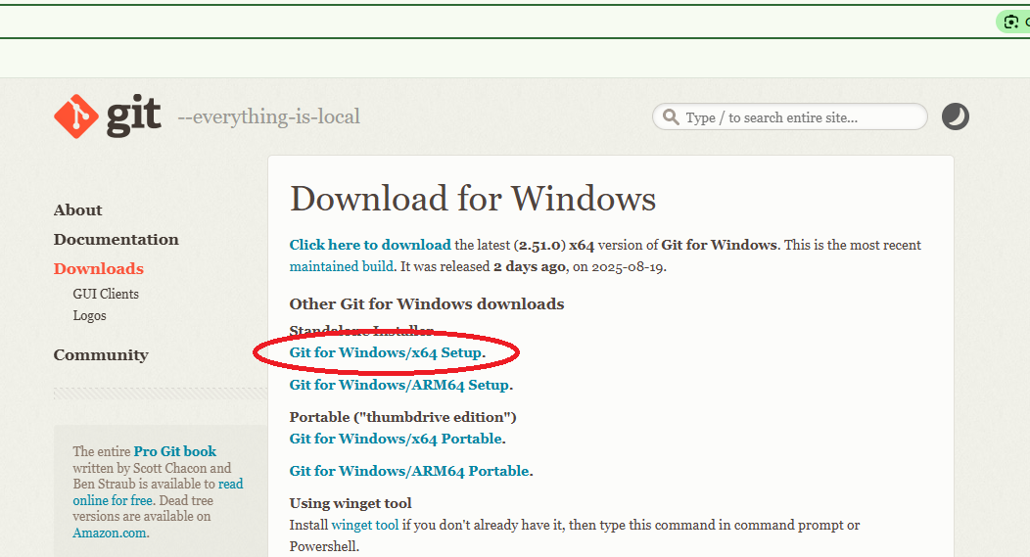
5. Install the down loaded file
6. Check weather the download is successful (open CMD type “git version” answer must be “git version 2.51.0.windows.1”)

**Cloning the global folder to local computer**

1. Create a folder in your local computer
2. Open cmd in side that particular folder and type “git clone “place the path””

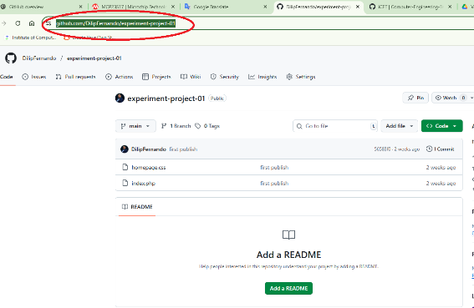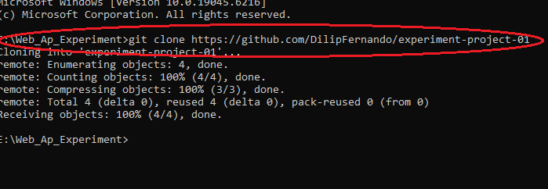

**Create Branches**

* git checkout -b branch-name
* git push -u origin branch-name

ones you push the command “git push -u origin branch-name” then your branch will be creating in the global repository

**Switch between to branch to main**

* git checkout Branch-A
* git checkout main

when you switch between this two branches locally folder will be change

**logging to git system**

* PS E:\Web_Ap_Experiment\experiment-project-01> git config --global user.name "Dilip"
* PS E:\Web_Ap_Experiment\experiment-project-01> git config --global user.email [fernando.dilip2@gmail.com](mailto:fernando.dilip2@gmail.com)

**Add changes to the repository**

* git add .
* git commit -m "first change"

if you run these above two commands only this will be updating only your local repository in your local computer.

if you want commit the global repository then include as below

* git add .
* git commit -m "first change"
* git push origin Branch-A

**Get latus update to your main folder from from the Branch**

Usually when you clone the project from main folder you will received only initial code, latus updates will be in project leader branch so you will miss latus update only cloning the main folder in global repository. so you need to merge his branch to your main folder so this as below

1. Open cmd in side that particular folder and type “git clone “place the path””

2 git merge origin/yasindu

Yasindu is the branch to be merge